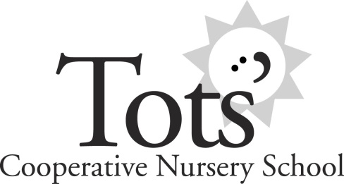
461 County Road Barrington, RI 02806
401-246-2021
www.totscooperative.org

PARENTS’ PLEDGE

A cooperative school is owned and operated by a group of parents and staffed by two professional teachers. Parents assist the teachers in the classroom and with the running of the school. We strongly encourage you to actively participate in the classroom and/or at fundraisers, meetings, and on classroom clean-up days.

You are there to share the school experience with your child. In our classes, we encourage you to participate in the class with your child once or twice a month- playing, learning, and making new friends together. You get to know our teachers, other parents, and all the children your child interacts with on a daily basis.

The Cooperative school recognizes that parents are the primary educators of their children. It encourages mothers and fathers to share their interests and talents in the classroom, on the Board of Directors, or on committees. These direct parental efforts and involvement make the cooperative a unique educational opportunity. The children grow in mind, body, and spirit as they are nurtured with acceptance and kindness by their teachers and other parents.

I agree to be an active member in my child’s education and help in any way possible by being a parent helper at my child’s school, helping with fundraising, attending meetings, and/or with school clean-ups.

____________________________________ ______________________
Parent Signature Date

